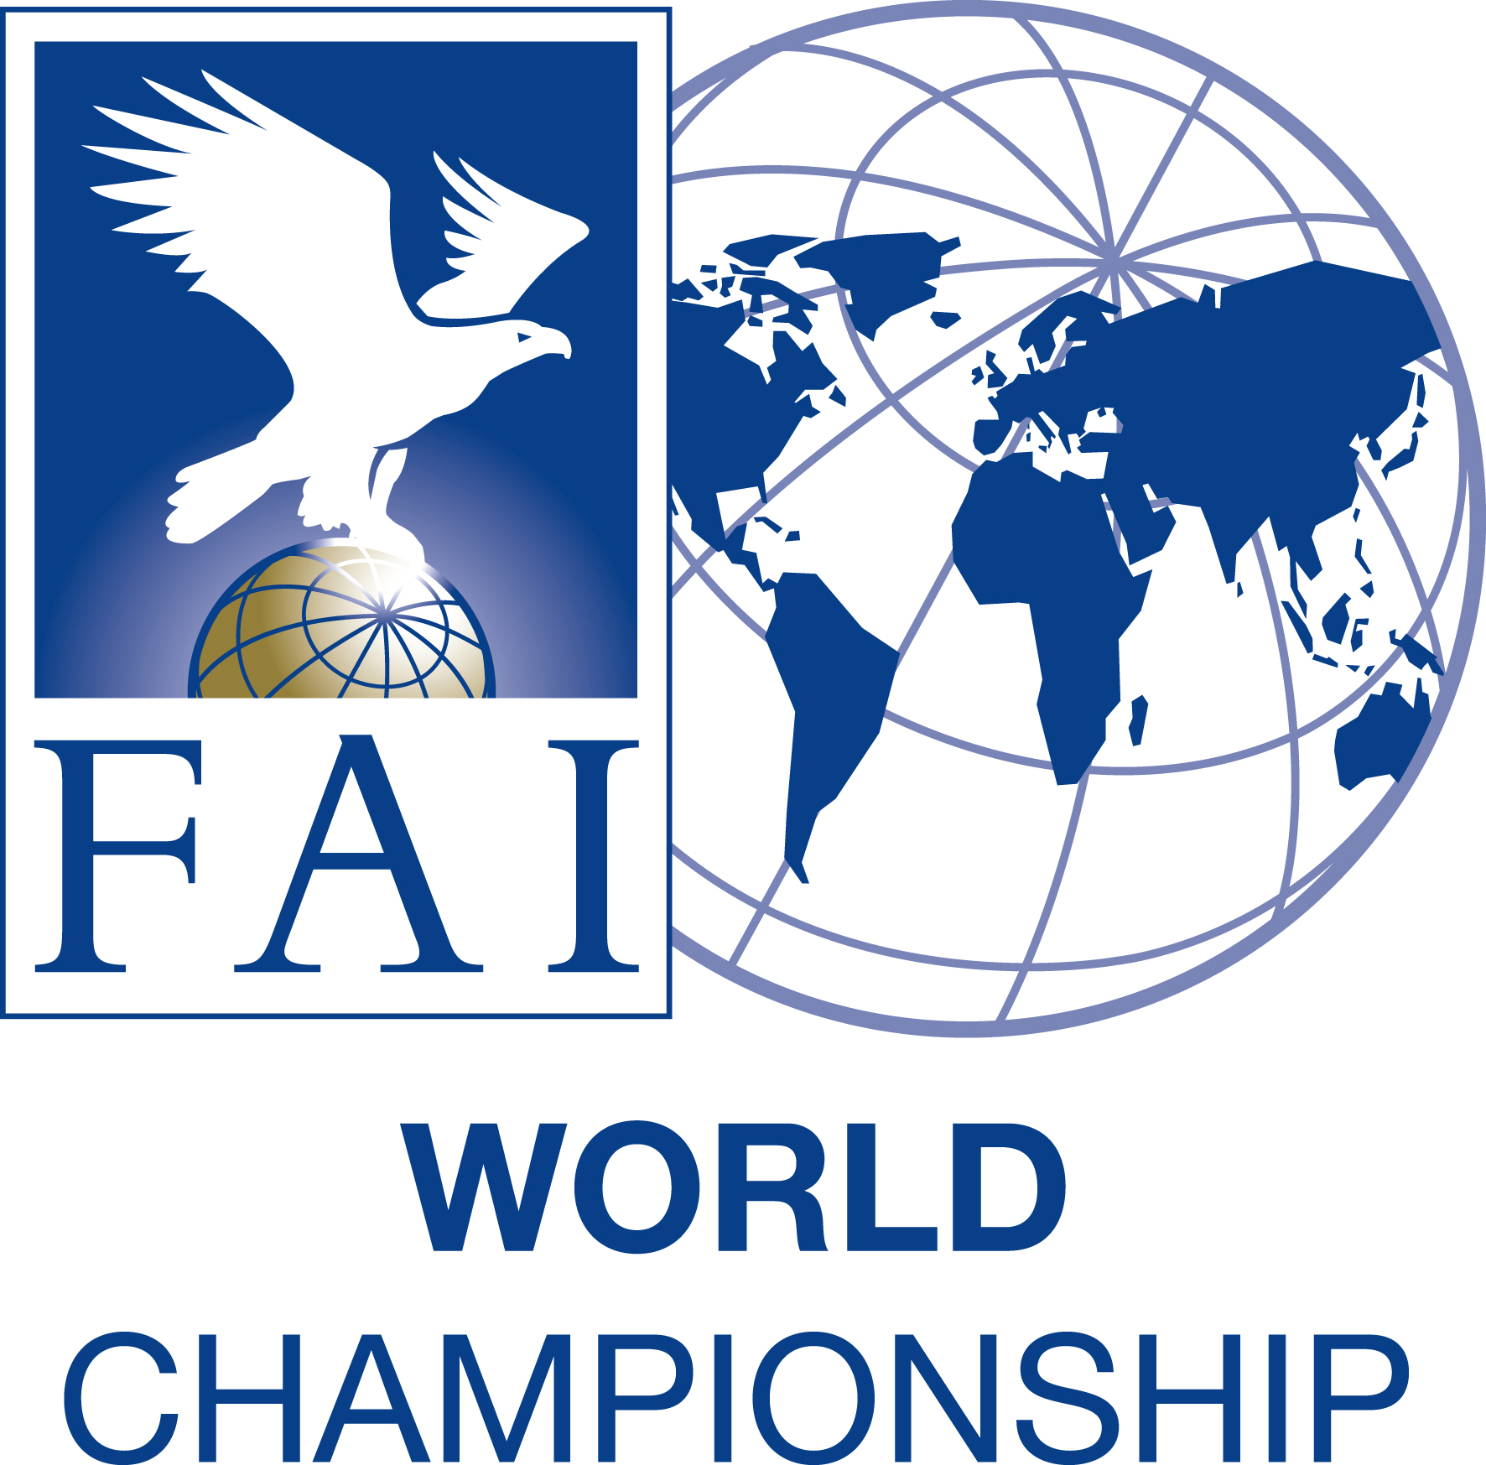

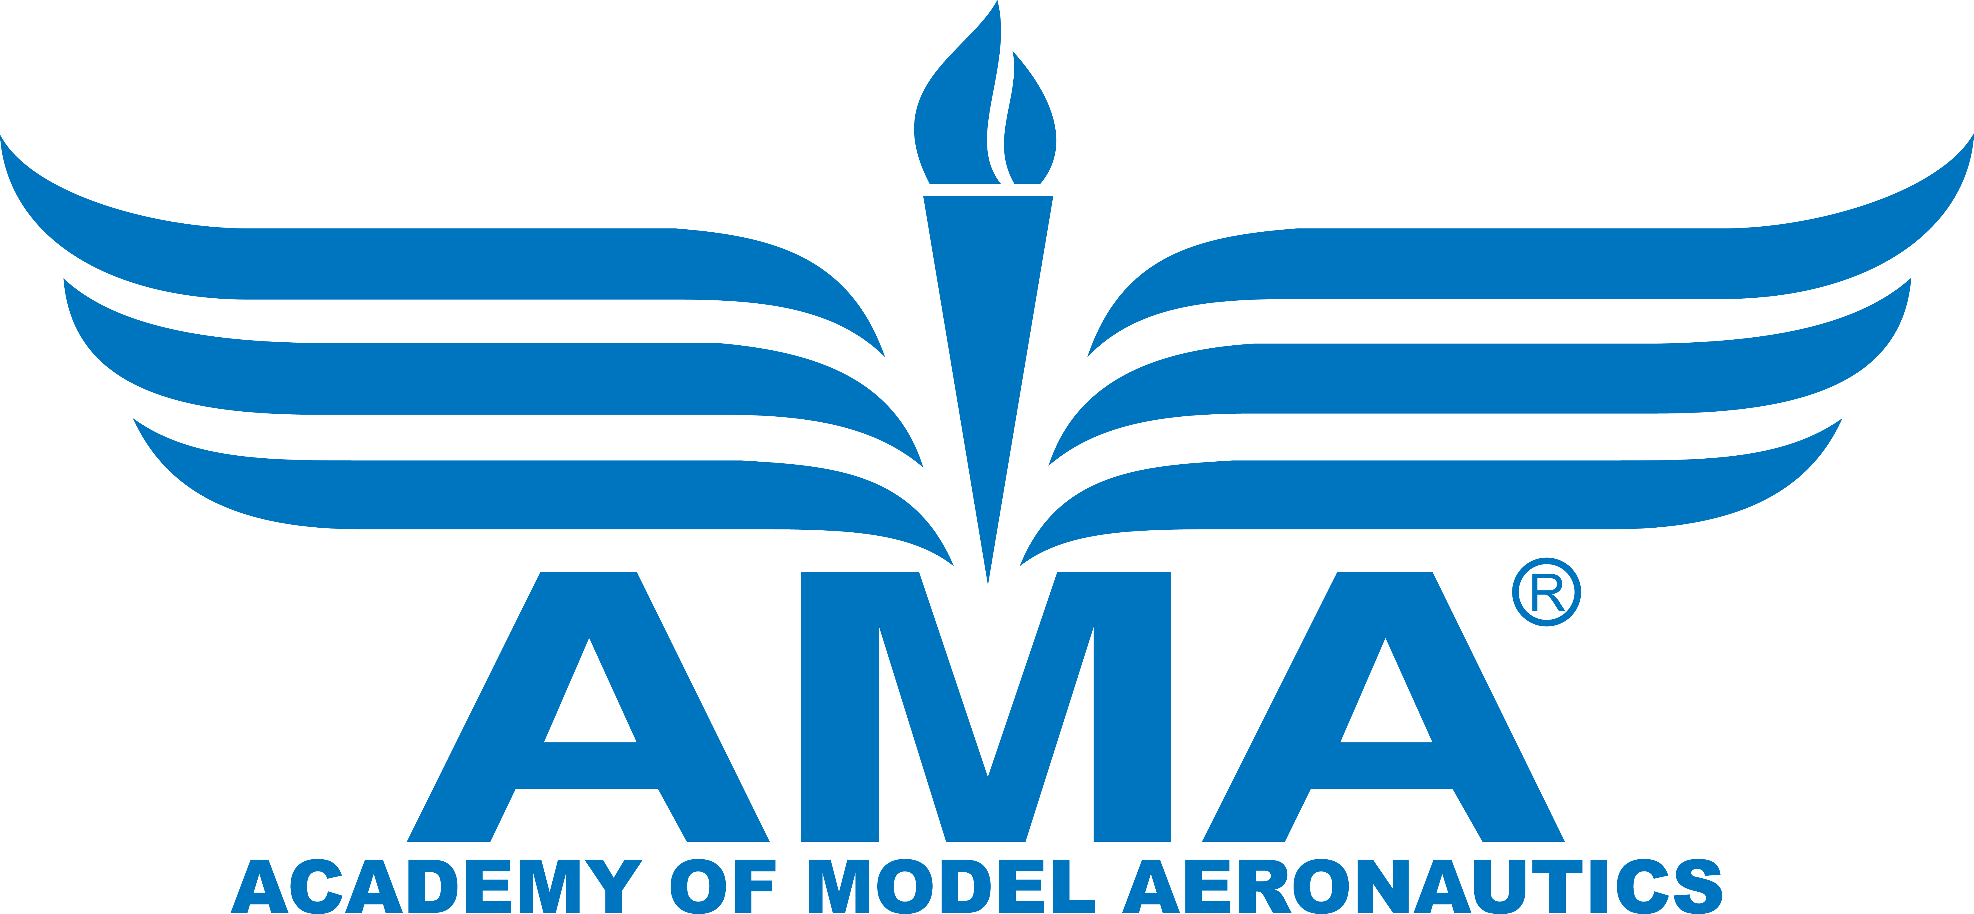
2024 FAI WORLD CHAMPIONSHIPS FOR F2 CONTROL LINE MODEL AIRCRAFT
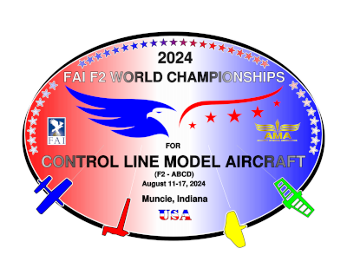
for Seniors and Juniors
Muncie, Indiana, USA
11-17 August 2024
PRELIMINARY ENTRY FORM

National Airsports Control of …………………………………….................................................................................................…
National Airsports Control Name ………………………………………………………………………………………………………….
Correspondence address: …………………………………………………………………………………………………………………
.............................................................................................................................................……………………………………….

NAC’s person in charge: ..............................................................

Phone: ................................ Fax.: ………………… e-mail:................................................
The National Team will consist of:

 | Number of Participants(Teams for F2C)
F2 TEAM MANAGER:
F2 ASSISTANT TEAM MANAGER:
: | F2A | F2B | F2C  Teams | F2D
COMPETITORS SENIOR:
COMPETITORS JUNIOR:
COMPETITORS FEMALE
REIGNING WORLD CHAMPIONS SENIOR:
REIGNING WORLD CHAMPIONS JUNIOR:
NUMBER OF PARTICIPANTS (Teams in F2C) in class:
F2D MECHANICS | -----------------------------------------------------
SUPPORTERS
TOTAL NUMBER OF PARTICIPANTS:

ORGANISERS:
National Airsports Control: Academy of Model Aeronautics
Local Organiser: Coalition of CL Special Interest Groups (NASS, PAMPA, NCLRA, MACA)
Contact person: Bill Lee
Mobile: 1-903-288-6029 email: Bill@WRLee.com
Official WChs website: https://2024CLWC.org
Official WChs e-mail: info@2024CLWC.org

NOTES:
1. The preliminary entry must be typed or written with block letters.
2. The preliminary entry form must be sent to organizer via email info@2024CLWC.org no later than 28 February 2024.

……………………........................... …………………………………………………………
Place and date Signature & Stamp of NAC official

